# M.B.M. Engineering College

# Department of Production & Industrial Engineering

Webinar on

*Kaizen: A Japanese Management Technique*

In association with

# Internal Quality Assurance Cell (IQAC)

**October 06, 2020**

**Session – Report**

**Patron**

**Prof. P. C. Trivedi**

Hon'ble Vice Chancellor

Jai Narain Vyas University Jodhpur

**Webinar Co-ordinators Conveners**

Mr. Amit Vishwakarma Prof. Milind Kumar Sharma, Director (IQAC) & Head P&IE

Mr. Prashant Athanker Dr. Lakhan Patidar, Assistant Professor (TEQIP-III), P&IE

Mr. Mohd Vaseem

Resource Person : **Prof. Milind Kumar Sharma**

Director (IQAC) & Head

Department of Production & Industrial Engineering

M.B.M. Engineering College

Faculty of Engineering & Architecture

Jai Narain Vyas University, Jodhpur

**Date :** October 06, 2020, Tuesday

**Time :** 11:00 AM to 12:00 Noon

**PREAMBLE**

The Department of Production & Industrial Engineering in association with Internal Quality Assurance Cell (IQAC), M.B.M. Engineering College, Faculty of Engineering & Architecture, Jai Narain Vyas University, Jodhpur conducted the webinar on *“Kaizen: A Japanese Management Technique”* for the students, scholars, teaching faculties, practitioners, consultants, entrepreneurs and people from industry and service sector.

MBM Engineering College is one of the oldest Engineering colleges in India established on 15th August 1951 by the government of Rajasthan, the college boasts of its high academic & technical standards having 12 departments including the recently added Petroleum Engineering stream. Later, this college was merged with the University of jodhpur in year 1962 presently known as the Faculty of Engineering & Architecture, of Jai Narain Vyas University, Jodhpur. This University has 39 departments and 6 centres.

Production & Industrial Engineering Department was established in year 1990 to impart quality education in the area of Production and Industrial Engineering. The department has well equipped CAD/CAM lab, Robotics, Industrial Engineering, Advanced testing lab, Product Design and Development Laboratories. The department has specialization in Manufacturing and Industrial Engineering, Automation (CAD/CAM&CAPP), Supply Chain Management, Performance Measurement, Information Systems.

**Internal Quality Assurance Cell (IQAC) – Vision**

To promote quality culture as the prime concern of Higher Education Institutions through institutionalizing and internalizing all the quality-enhancing and sustaining initiatives taken with internal and external support.

**Objective**

The primary aim of the IQAC is

* To develop a mechanism to promote conscious, consistent and catalytic action plans to improve the academic and administrative performance of the institution.
* To promote institutional quality enhancement and sustenance through the internalization of quality culture and institutionalization of the best practices.

IQAC offers various intra- and inter-institutional workshops and seminars/webinar on quality- related themes and promotion of quality circles.

Prof. Milind Kumar Sharma was Convener and Dr. Lakhan Patidar was Co-Convener of the programme. Total number of participants showed their interest for webinar on Kaizen were 941. Out of them many people have belonging to very reputed institutes and university. Participants have registered in India from all region as well as some of the participants having registered from others country like Bhutan (08), UK (01), Bangladesh (01), Egypt (04), Philippines (01) Nigeria (01) etc. Of these, around 160 participants took part in online webinars which included teachers (37%), students: UG, PG and PhD scholars (47%), practitioners, consultants, entrepreneurs and people from the industry and services sector (16%).

Prof. Milind Kumar Sharma, Director (IQAC) & Head, Department of Production & Industrial Engineering, M.B.M. Engineering College, Faculty of Engineering & Architecture, Jai Narain Vyas University, Jodhpur delivered the lecture.

# The course content delivered in the webinar is as follows:

The impact of Kaizen in day-to-day activity with best suitable real life examples was discussed in this session.

The Co-Convener of the webinar Dr. Lakhan Patidar briefed about the IQAC and session. The keynote speakers of this webinar were Professor Milind Kumar Sharma, Director Internal Quality Assurance Cell (IQAC) and Departmental Production and Industrial Engineering, Faculty of Engineering, MBM Engineering College, Jai Narayan Vyas University Jodhpur. The keynote speaker explained the usefulness of "Kaizen: A Japanese Management Technique" in various research areas through this webinar and stated that kaizen can be a game changer for strategy organizations. Neither capital nor sophisticated training sessions are required for kaizen. He motivates employees to make their own suggestions on breaking traditional organizational silos and paves the way for leadership, creative thinking and a sense of ownership with the organization. He discussed the basic concepts used in the day to day operation with best suitable real life examples which are essential for the understanding of Kaizen philosophy. He inspired the audience by lively interacting on topics to take proactive initiatives and propose reforms on how things should be done, rather than feeling powerless in their respective roles. He emphasized that kaizen can help improve day-to-day operations, eliminate wasteful and non-value-added activities, increase work quality and productivity.

Also the feedback about the session was collected from all the participants to improve the sessions that will be conducted in the mere future. The sample details collected from the participants is as follows:

|  |  |  |  |  |  |
| --- | --- | --- | --- | --- | --- |
| Sno | Timestamp | Email Address | Name | Affiliation | Mobile no. |
| 1 | 10-6-2020 11:41:32 | spkavya1@gmail.com | Miss KAVYA SIDDESHWAR | Bharathidasan University, Trichy | 9483133012 |
| 2 | 10-6-2020 11:59:30 | niva.elna.varghis@gmail.com | Ms. Niva Elna Varghis | The Indian Community School, Kuwait | 99853183 |
| 3 | 10-6-2020 12:04:39 | amitkumar.d@srmus.edu.in | Mr. Amit Kumar Dutta | SRM University Sikkim | 9733450793 |
| 4 | 10-6-2020 11:26:41 | ks.irfan@gmail.com | Dr. Irfan Mumtaz KS | AL AMEEN INSTITUTE OF MANAGEMENT STUDIES | 7349734311 |
| 5 | 10-6-2020 12:01:07 | padhi.ghcl@gmail.com | Haranarayan Padhi | Dy. General Manager - Process , GHCL LTD , SUTRAPADA , GUJARAT | +919099093045 |
| 6 | 10-6-2020 12:26:28 | rajat.k.ghosh@relianceada.com | Mr. Rajat Kanti Ghosh | Sasan Power Ltd. | 9350813859 |
| 7 | 10-6-2020 11:17:15 | snjblimbu.hgsg@gmail.com | Sanjeeb Limbu | North Eastern Hill University, Shillong | 9435002077 |
| 8 | 10-6-2020 11:17:20 | jrandhawa304@gmail.com | Dr. Jugraj Singh Randhawa | Khalsa College of Engineering and Technology Amritsar | 9780363388 |
| 9 | 10-6-2020 12:22:23 | dr.chandreshkumarpandey65@gmail.com | SANSKAR PANDEY | Humber college Toronto ontorio Canada | 9450530290 |
| 10 | 10-6-2020 12:21:19 | sindhurakannappan2018@gmail.com | Sindhura.K | University of Madras | +919952962088 |

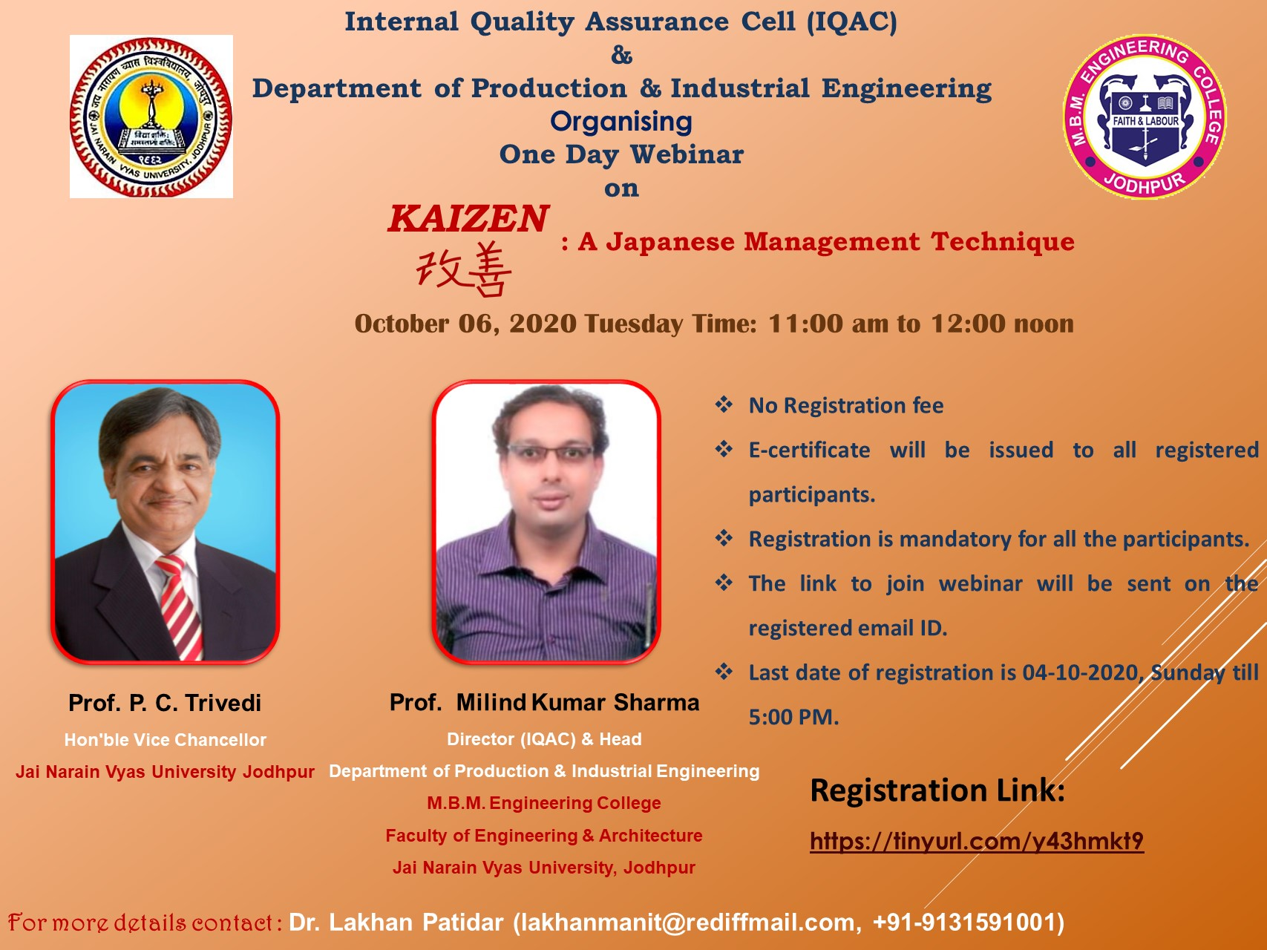

**Kaizen: A Japanese Management Technique Webinar Brochure**

This programme is arranged in the motive of sharing the knowledge and practical experience of Professor Milind Kumar Sharma, who has a long years of experience in research. The overall organization and deliverance of the webinar was helpful and satisfied the participants.

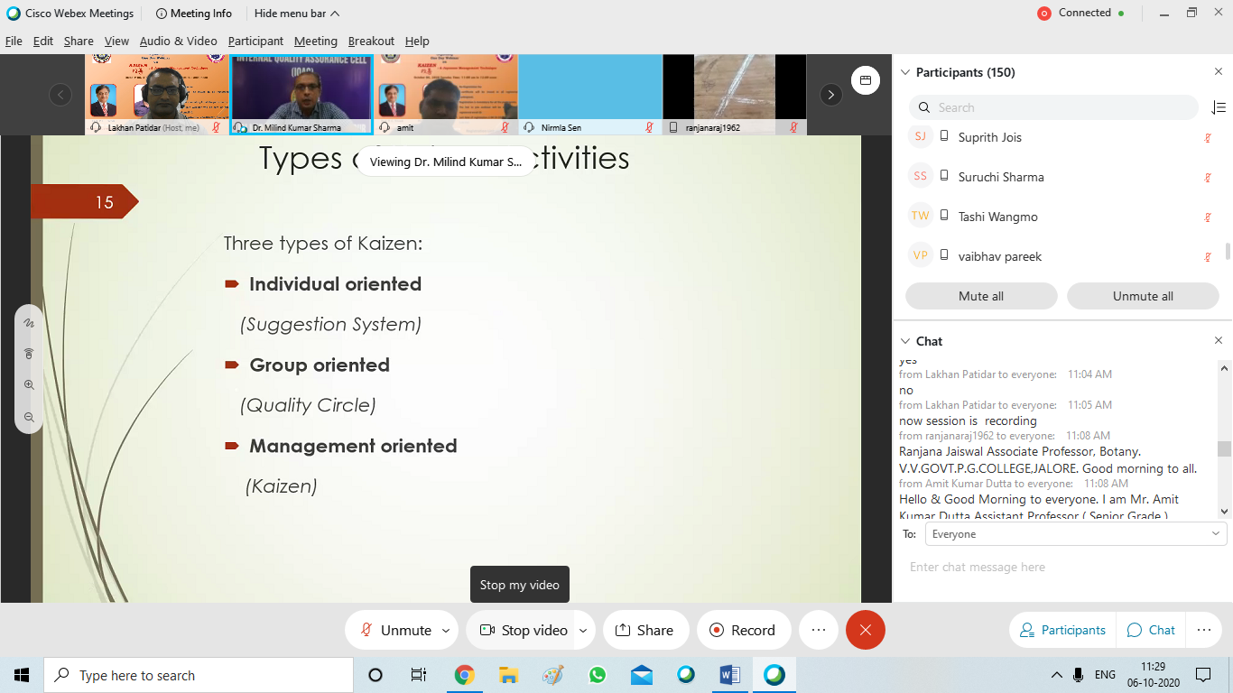

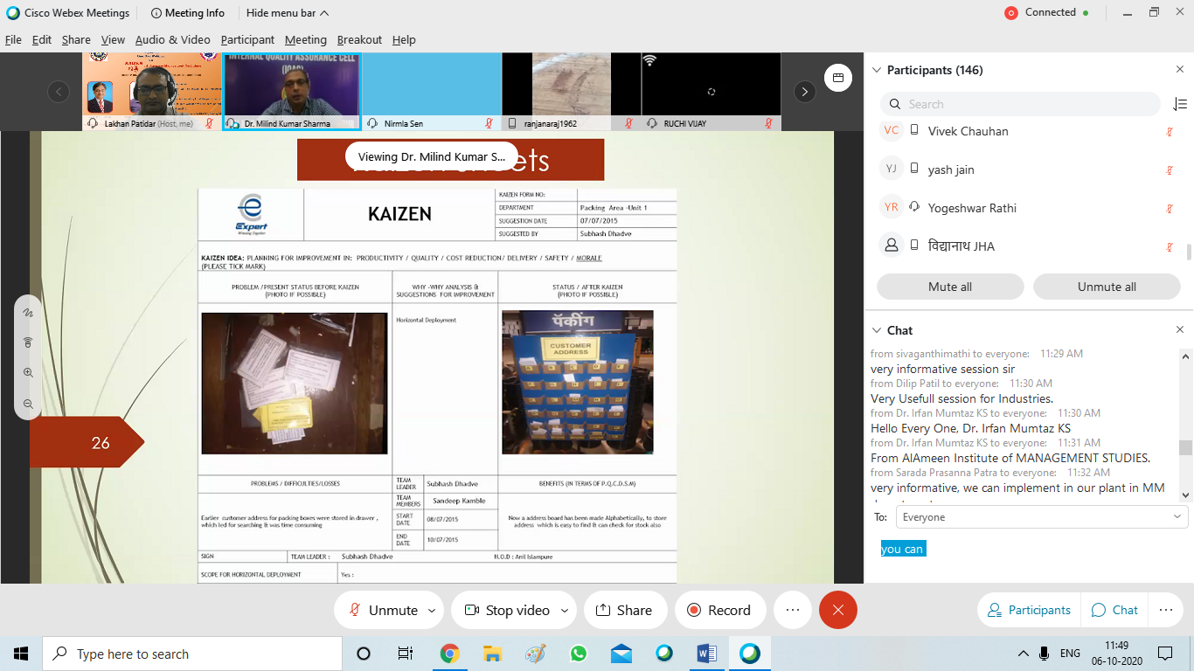

**(Professor Milind Kumar Sharma interacting with participants)**

# Feedback Form

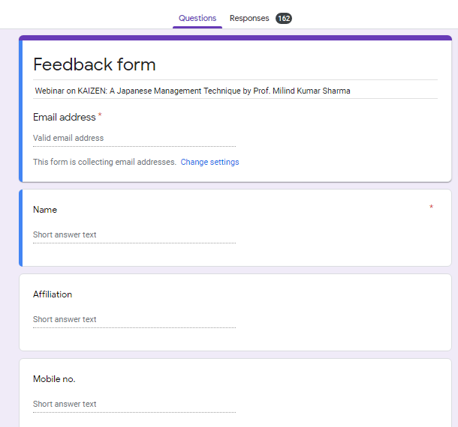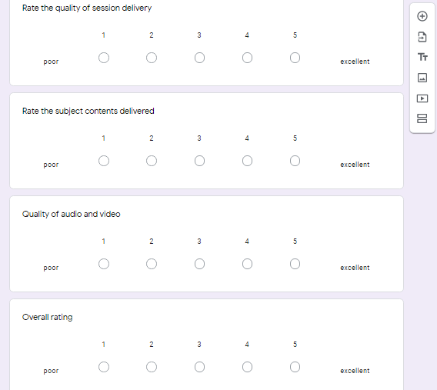

*Feedback form:* <https://docs.google.com/forms/d/e/1FAIpQLSdgG_Qqtodvhyw5-mRnGZznMbA_kQ6OEJjciaoNxGNbqmTJAw/viewform?usp=sf_link>

**Sample Feedback Responses obtained through Google form from the participants.**



The objective of the webinar was achieved. The overall session discussion benefitted the faculty members, students: UG, PG & PhD scholars, practitioners, consultants, entrepreneurs and people from industry and service sector. This webinar would help the participants help in improving day-to-day operations, elimination of waste & non value adding activities, enhanced work quality and productivity. Nonetheless, it is not an antidote for every challenge an organization may encounter, implementing Kaizen can result into consistent and long-term growth. The webinar concluded with the distribution of e-certificates to the participants.

------------------------------------------------------ END OF REPORT ----------------------------------------------------